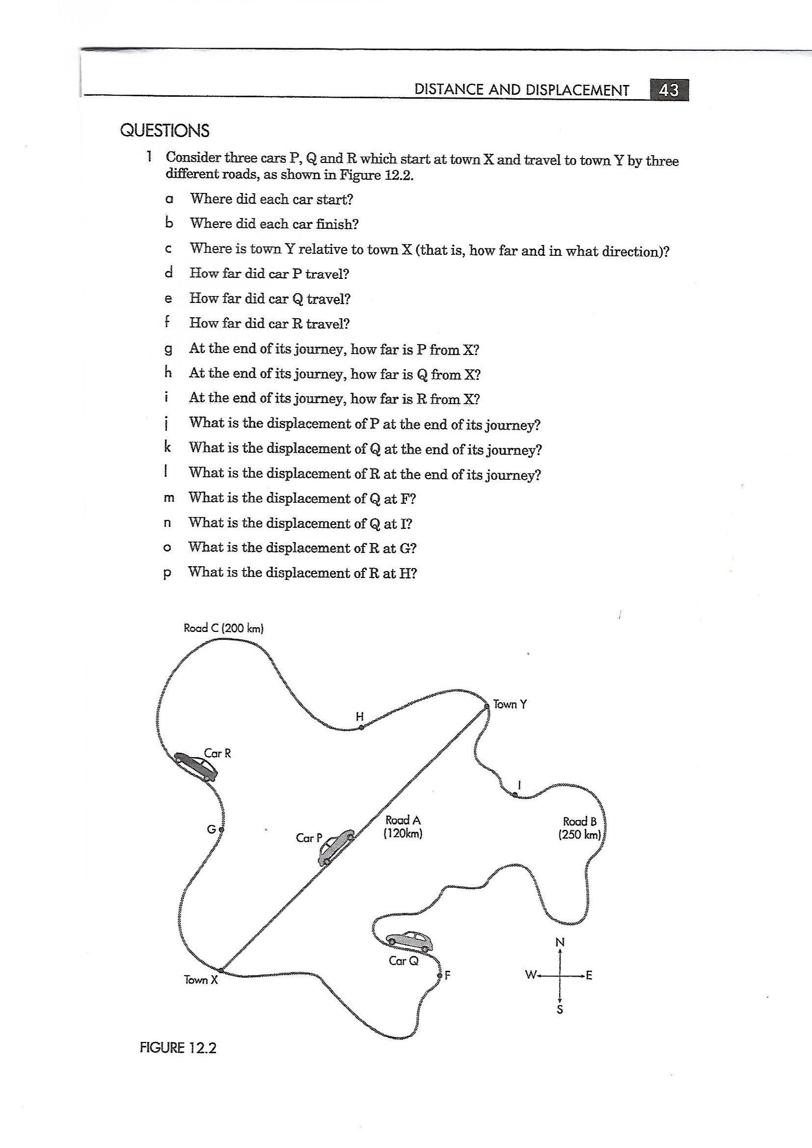



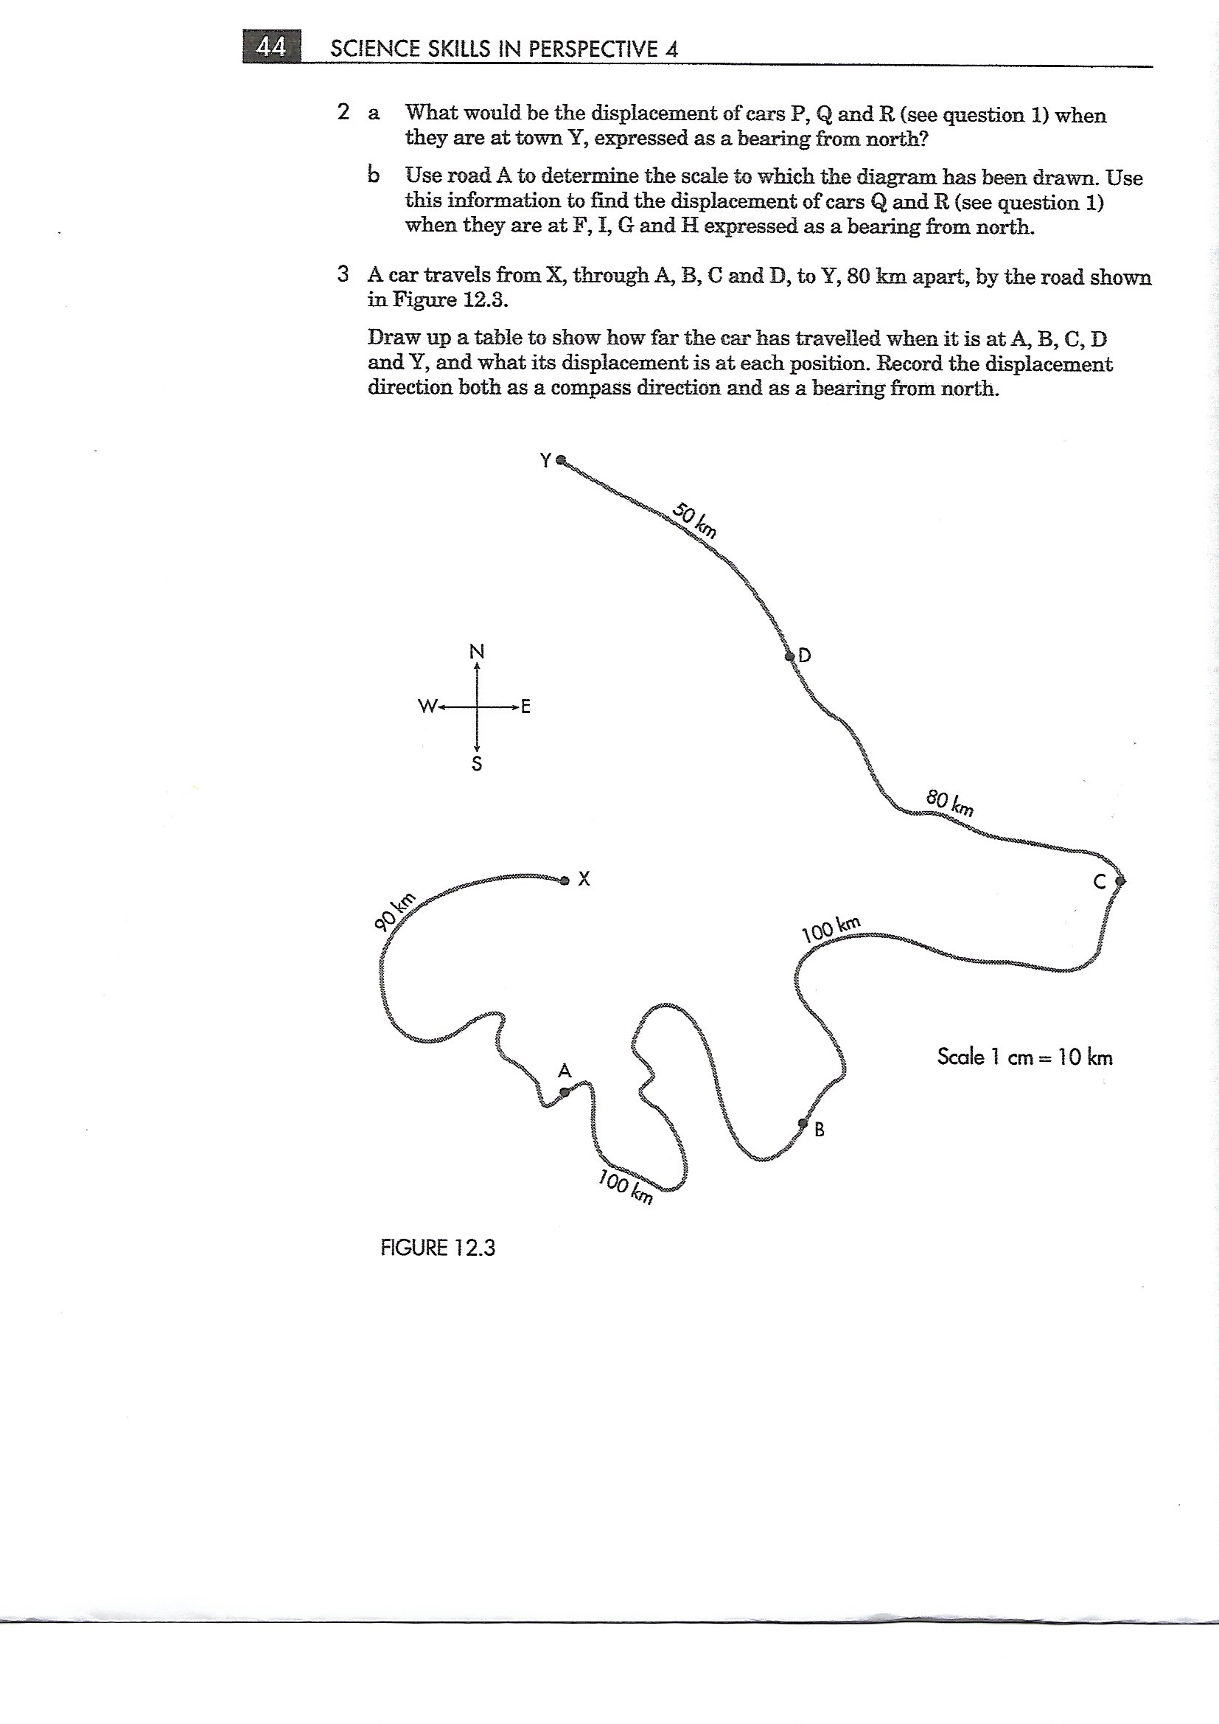

|  |  |  |
| --- | --- | --- |
| Car at point | Distance from X | Displacement from X |
| A |  |  |
| B |  |  |
| C |  |  |
| D |  |  |
| Y |  |  |

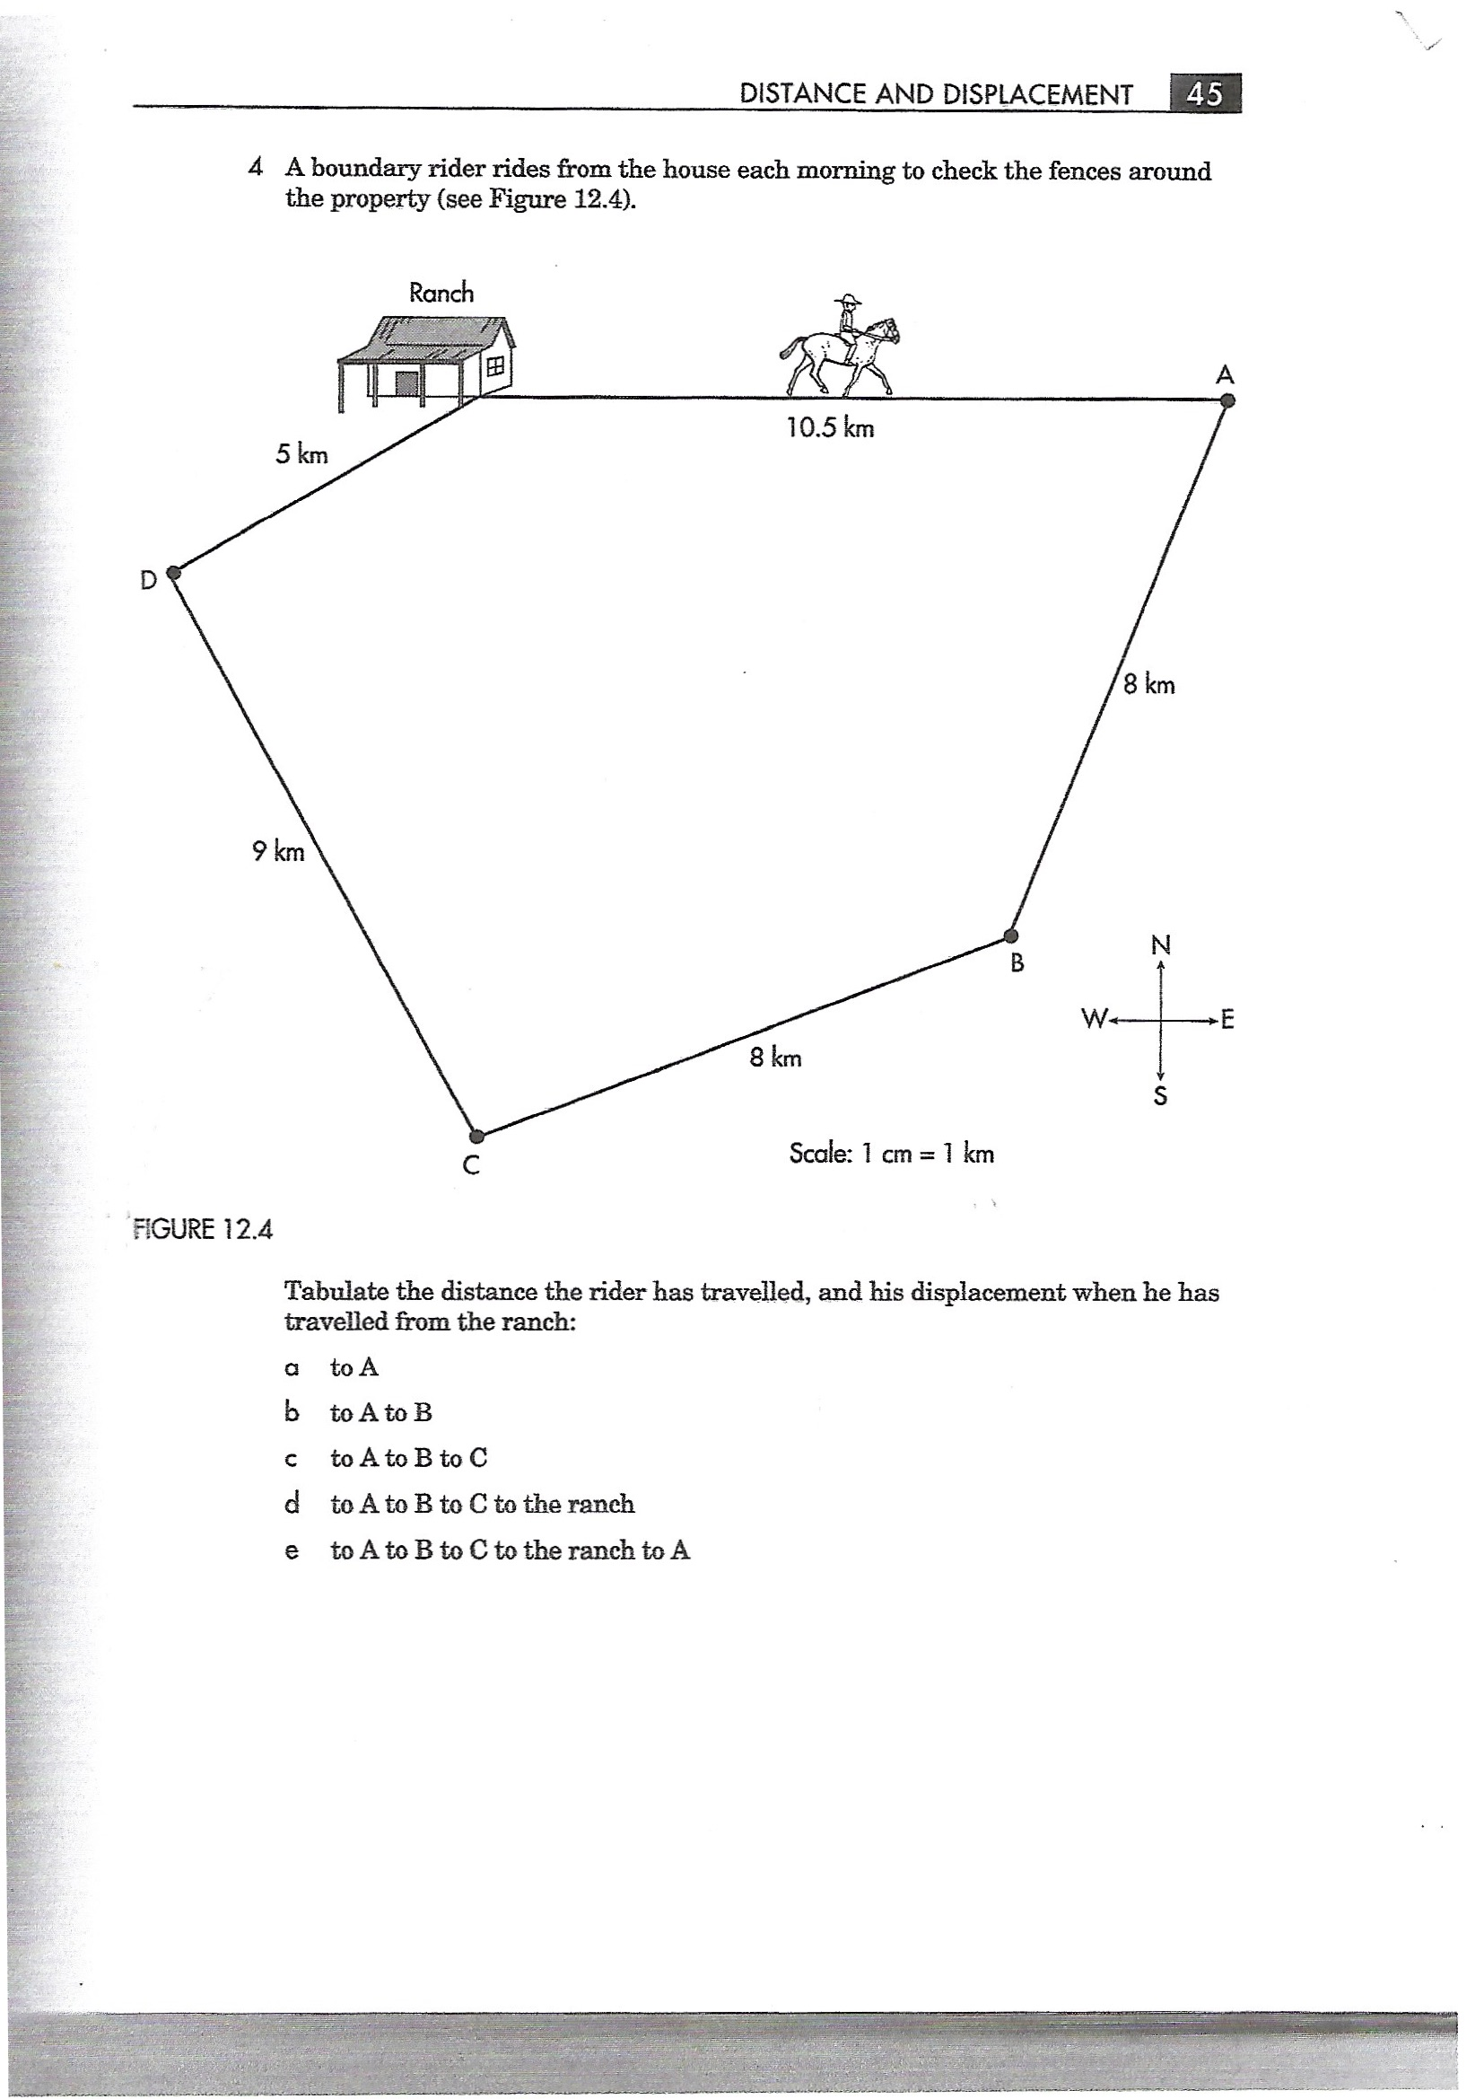

|  |  |  |
| --- | --- | --- |
| Rider from the ranch | Distance | Displacement |
| To A |  |  |
| To A to B |  |  |
| To A to B to C |  |  |
| To A to B to C to the ranch |  |  |
| To A to B to C to the ranch and to A |  |  |

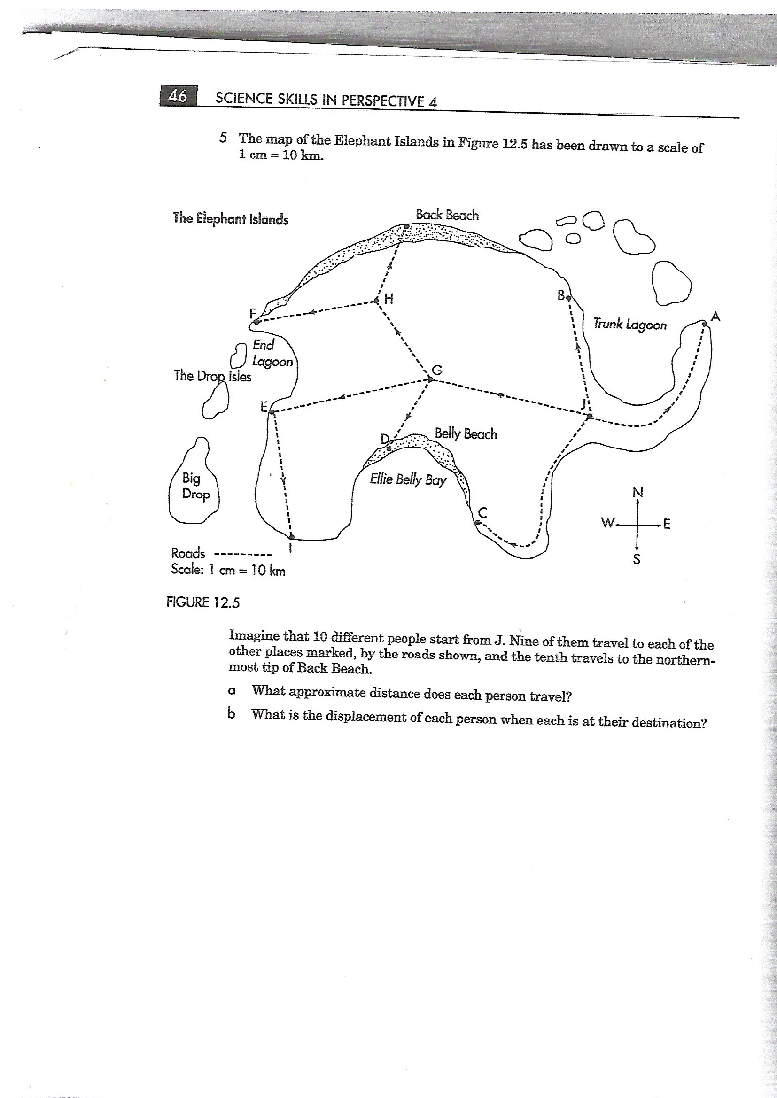

|  |  |  |
| --- | --- | --- |
| Person | Distance | Displacement |
| Person 1 travels from J to A |  |  |
| Person 2 travels from J to B |  |  |
| Person 3 travels from J to C |  |  |
| Person 4 travels from J to D |  |  |
| Person 5 travels from J to E |  |  |
| Person 6 travels from J to F |  |  |
| Person 7 travels from J to G |  |  |
| Person 8 travels from J to H |  |  |
| Person 9 travels from J to I |  |  |
| Person 10 travels from J to Back Beach |  |  |